**Assignment-10**

**Topics Covered:**

**Pandas, joins between pandas, filter data in pandas and sorting**

**Reading datafrom pandas:**

**Code:**

**import pandas as pd  
  
# Read data from a CSV file  
df1 = pd.read_csv('EmployeeDetails.csv')  
df2 = pd.read_csv('Dept_details.csv')  
import pandas as pd  
  
# Printing the entire DataFrame  
print(df1)  
print(df2)**

**Output:**

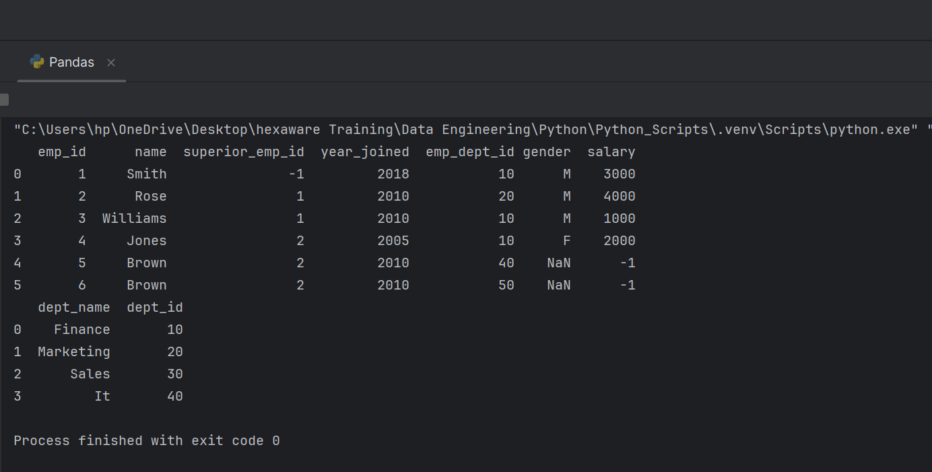

**Joins**

**Inner Join:**

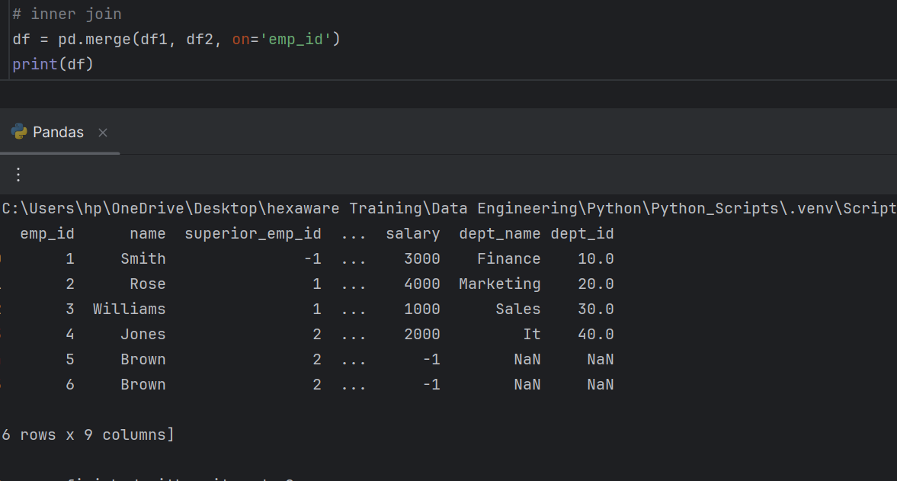

**Left join:**

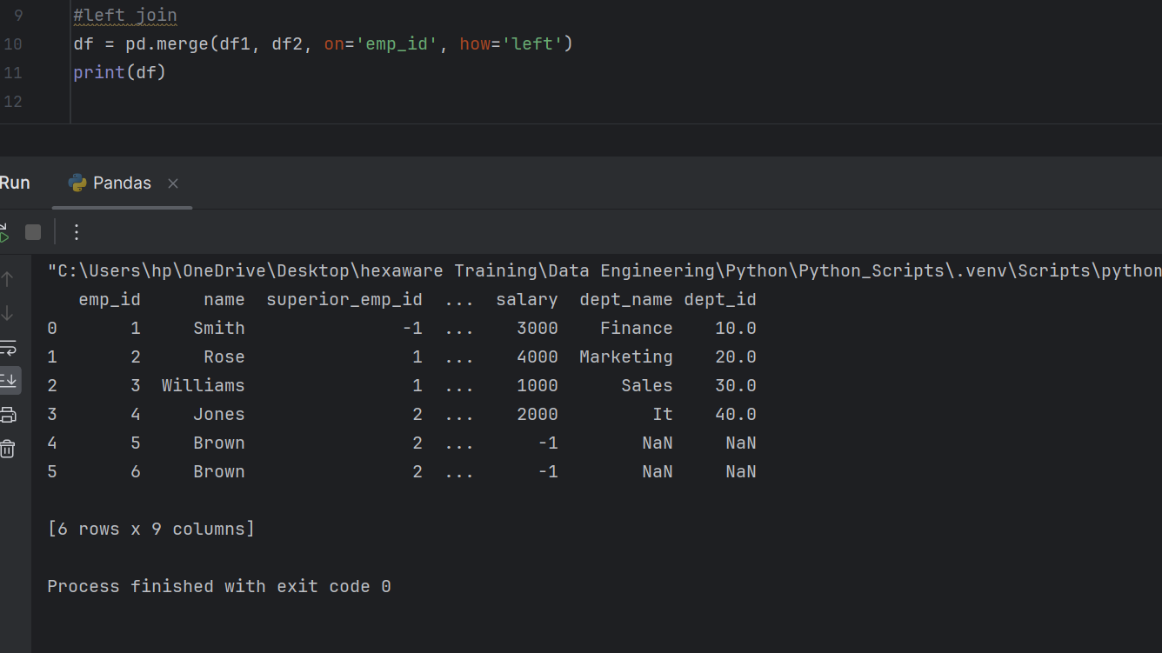

**right join:**

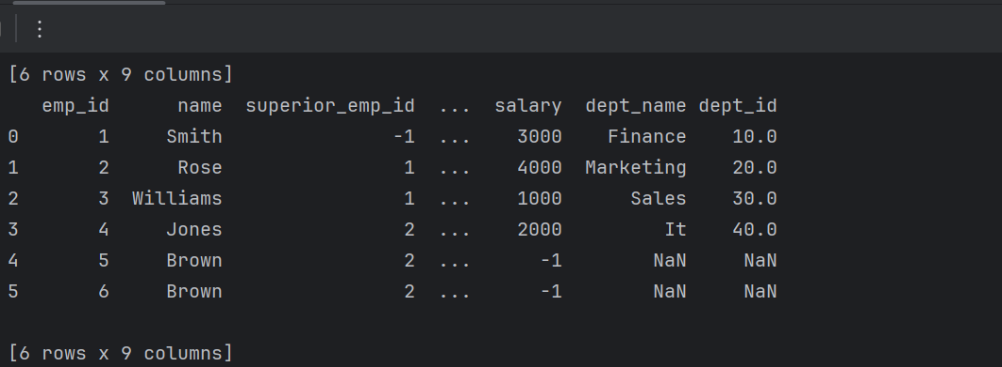

**Outer Join:**

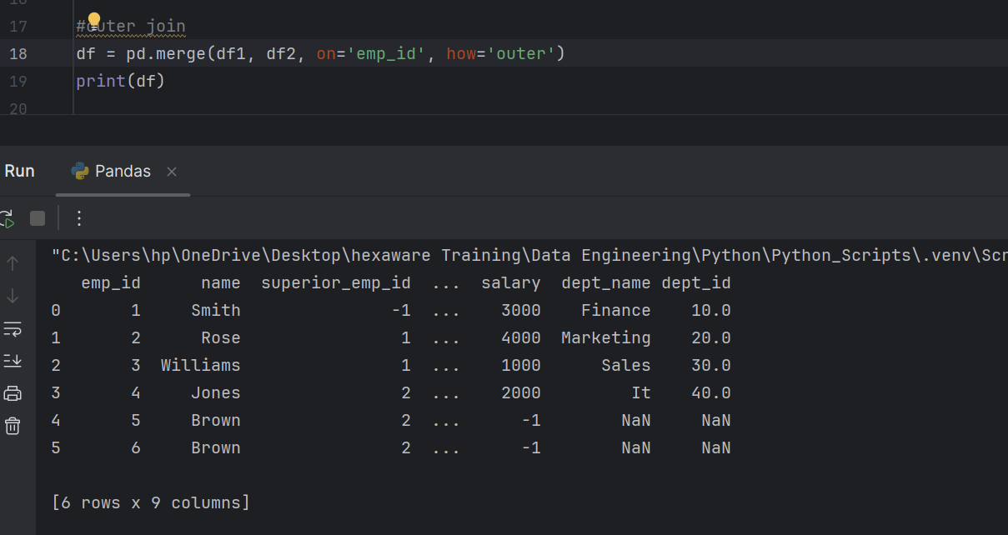

**Filtering Data in Pandas**

**Sorting in Pandas:**

